Dividend payout ratio

The dividend payout ratio is the ratio of the total amount of dividends paid out to shareholders relative to the net income of the company. It is the percentage of earnings paid to shareholders via dividends. The amount that is not paid to shareholders is retained by the company to pay off debt or to reinvest in core operations. It is sometimes simply referred to as simply the payout ratio.

​

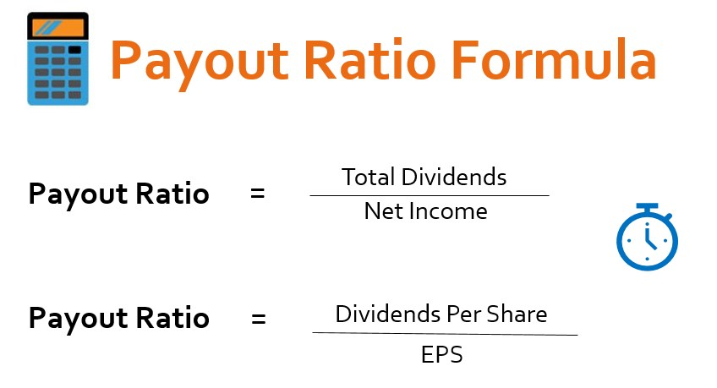EPS = Earnings per share  
Example:

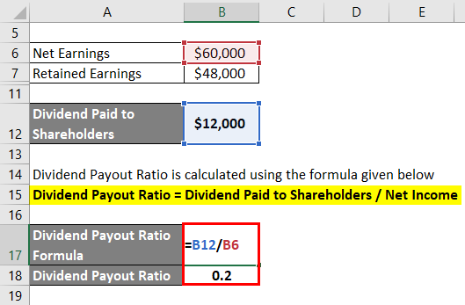

Dividend:

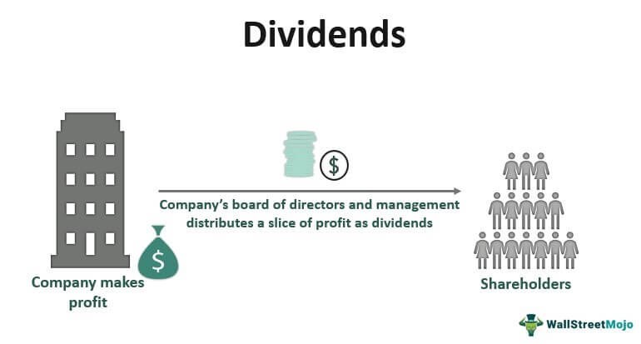

Is a higher dividend always good?

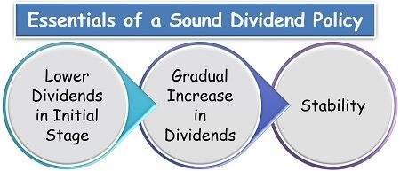

Dividend per share:

Dividend per share (DPS) is the sum of declared dividends issued by a company for every ordinary share.

Ordinary shares, also called common shares, are stocks sold on a public exchange.  
  
